**Raj Singh: COSC 4353 Software Design**

**Group 10 - Assignment 1**

**GROUP 10: Satya Sai Sribhashyam,Tasneem Patel, Jenish Bhadola**

**1. Discuss your initial thoughts in detail on how you will design this application? (2 points)**

* The building process will be focused more on user functionality and usability meaning we will be making a user-friendly interface design.
* We are planning on using tools such as SQL, HTML and CSS for the front-end design. For the back-end we are planning to use python and C++ with compilers/integrated development environment such as Pycharm and Visual Studio Code. As for the website UI design we will be using tools such as Adobe XD and Photoshop.
* We are planning to use MySQLto create a database to keep track of all data from the users and have a good profile management system
* The website design/software will include a modular login system that allows for user authentication and also lets new users to create an account in the website
* We hope to use the APIs to get fuel quotes for any particular location the user requests and provide it accordingly
* We will be making data sheet of all the user fuel history, which will help us to keep track of all the transactions done using the application

**2. Discuss what development methodology you will use and why? (2 points)**

For this project we are planning on using the agile over the waterfall methodology, because of the faster development process speed provided by the agile methodology. In this project a lot of requirements and details have already been provided by the client, therefore, it is imperative that there is a constant collaboration with the stakeholders, which is one of the main advantages of the agile methodology. Moreover, since the agile methodology manages a project by breaking it up into several phases any required changes can be made easily without disrupting the final product. This method would also provide an opportunity for client feedback allowing developers to make smooth changes as mentioned before.

Since agile method is iterative, incremental, and at the end of each increment we’re releasing the results, producing it to customers, means that they don't have to wait all the way till the end to see the end product, since they can give us the feedback, they can also find some bugs or issues that will also give us time to fix those while they are working through the process. Leads to good quality, quick results. The Extreme Programming framework of agile method would be suitable to use for our product, since the phases can be done in very small iterations and in each iteration we can add more customer-friendly values or features to the software as customers start using it and give their feedback.

**3. Provide high level design / architecture of your solution that you are proposing? (6 points)**

**Layered Software Architecture:**

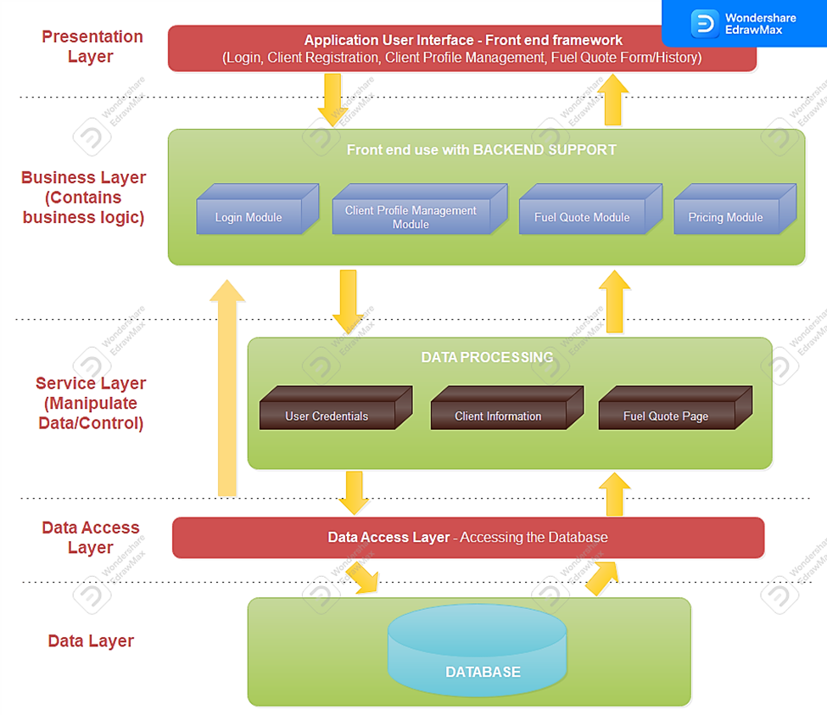

**UML Diagram:**

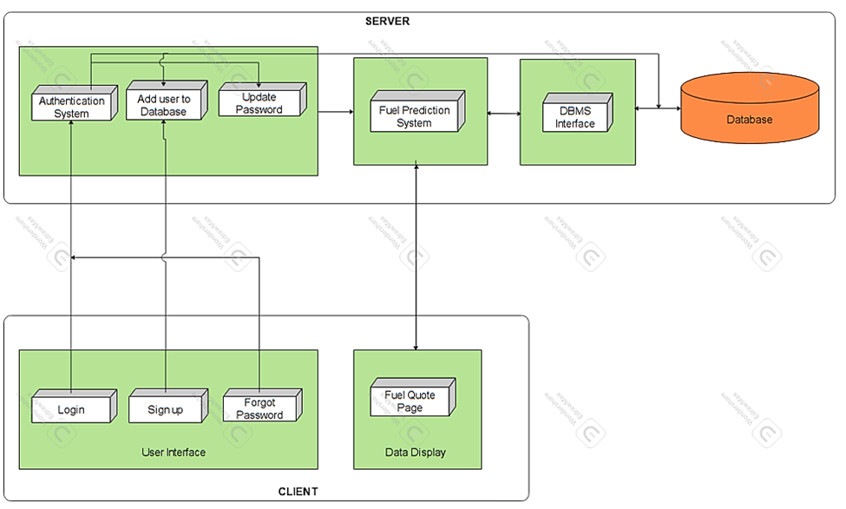

**4. IMPORTANT: list who did what within the group. TAs should be able to validate in GitHub, otherwise team members who didn't contribute will receive a ZERO.**

Fill in this table, provide as much details possible:

**While the three of us helped each other with the questions by discussing different possibilities and methodologies that may enhance the workflow of this project, each member specifically worked on one separate question to contain the information. Satya Sai Sribhashyam worked on question 1, Jenish Bhadola worked on question 2, and Tasneem Patel worked on question 3.**

| Group Member Name | What is your contribution? | Discussion Notes |
| --- | --- | --- |
| Tasneem Patel | Question 3 | Designed the layered high level architecture, and also helped in making the UML diagram |
| Satya Sai Sribhashyam | Question 1 | Discussed the possible tools we will be using during the process of creating/designing the website |
| Jenish Bhadola | Question 2 | Discussed the possible pros and cons of both the methodologies evaluating on why and which methodology would prove to be the most efficient. |